**Angular JS Handson - 1 => Day - 1 => Session -1**

**Explain the characteristics of a single page application (SPA) :**

A single page application (SPA) is a web application or website that interacts with the user by dynamically rewriting the current webpage with new data from the web server, instead of the default method of a web browser loading entire new pages.

The main advantage of single-page applications for end-users is, of course, the speed at which the app loads as well as the ability to work offline. SPA offers a linear user experience, which means that it is easy to navigate the website and understand where to find this or that thing.

Single-page applications are great on mobile devices too, since most of the time, all the users need is to scroll (for example, Facebook wall). We do not have to click on any links.

**SPA Lifecycle :**

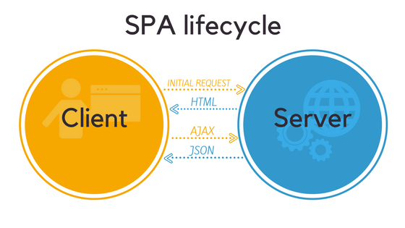

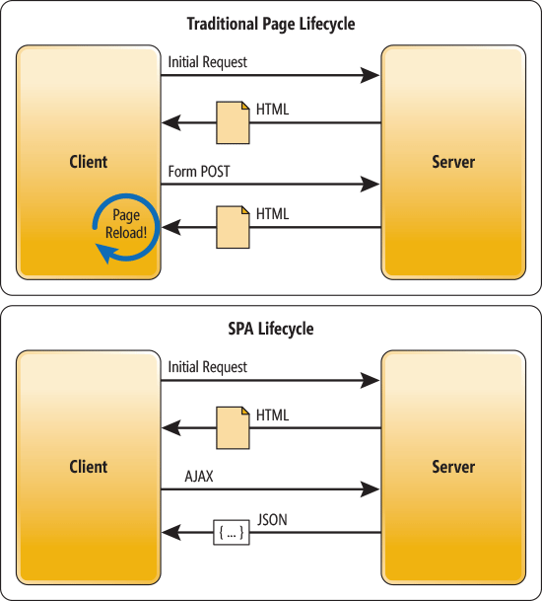

The initial request is sent to the server from the client side (which is also termed as the initial request). Post the sending of the request, the respective html document is sent in return from the server to the client side for display.

In an SPA after the first page loads, all interactions with the server happens through AJAX calls. These AJAX calls return data - not markup - usually in JSON format. The app uses the JSON data to update the page dynamically, without reloading the page. When the JSON is retrieved the app uses a data-binding JS framework like Angular or Knockout to bind the JSON result to the HTML.

JavaScript Objects Screenshots :

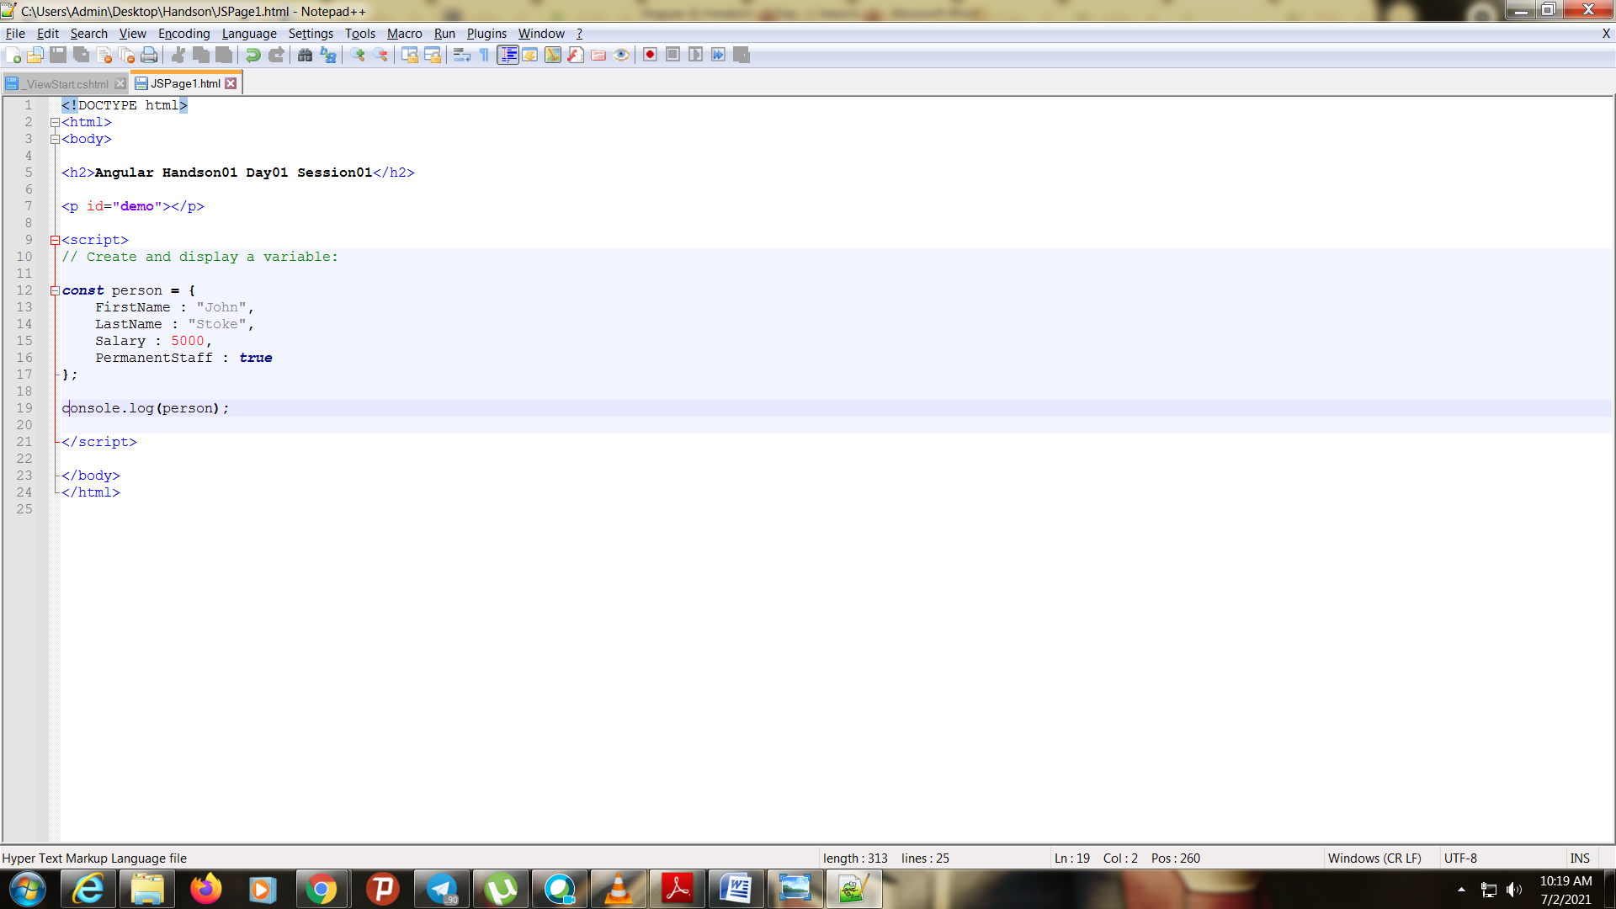

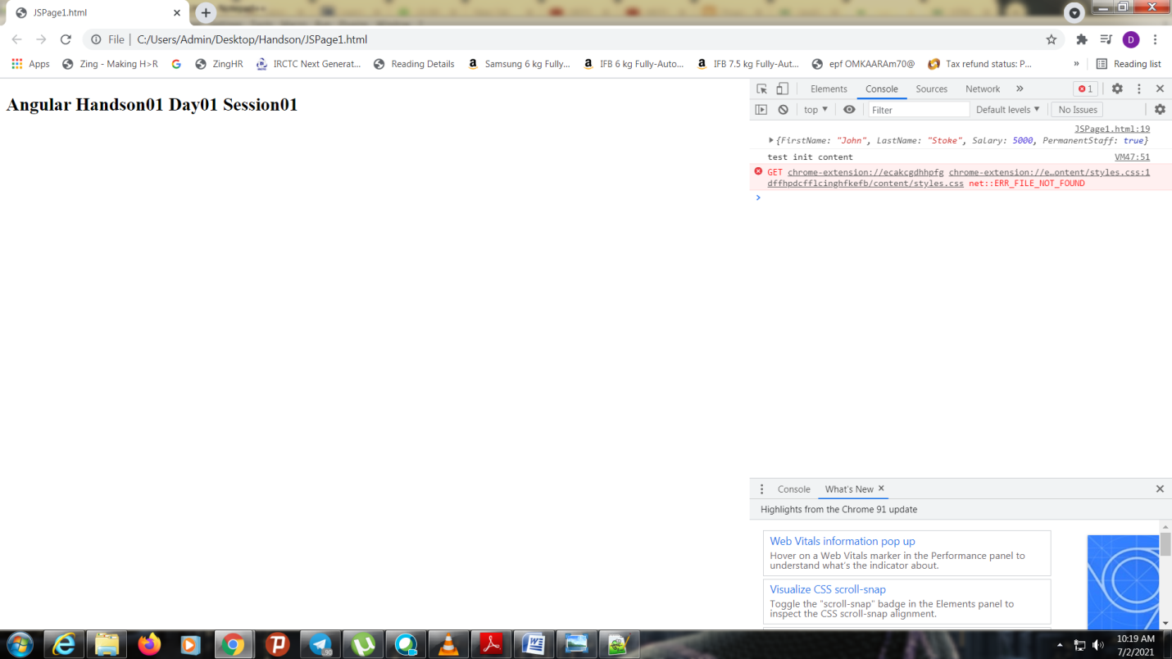

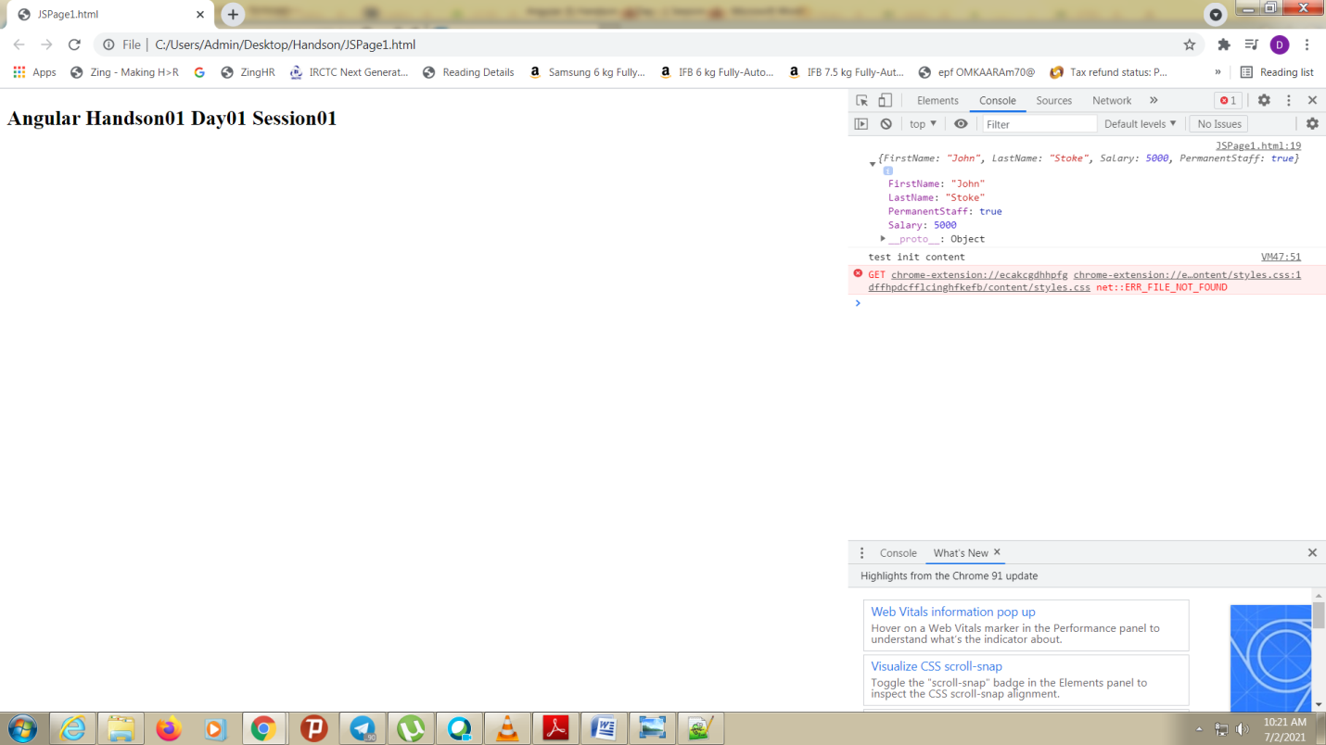

**JSON Text to JSON Object Parsing :**

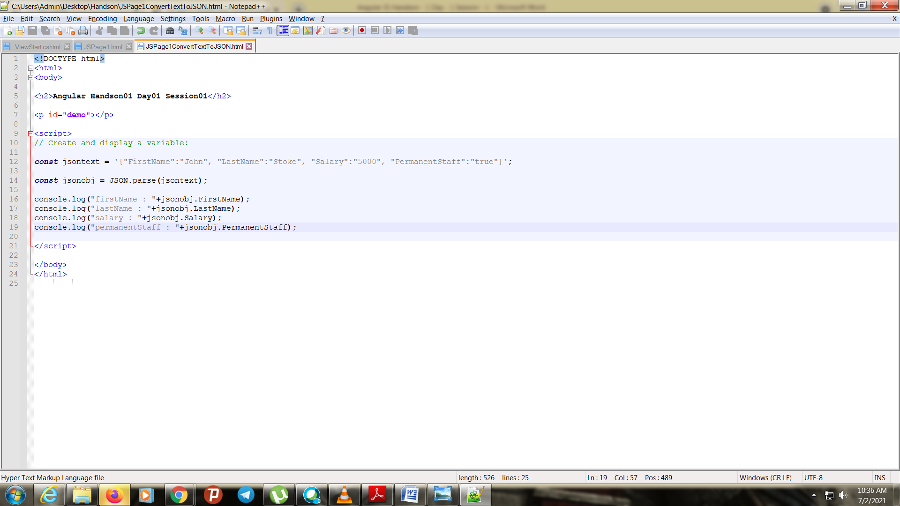

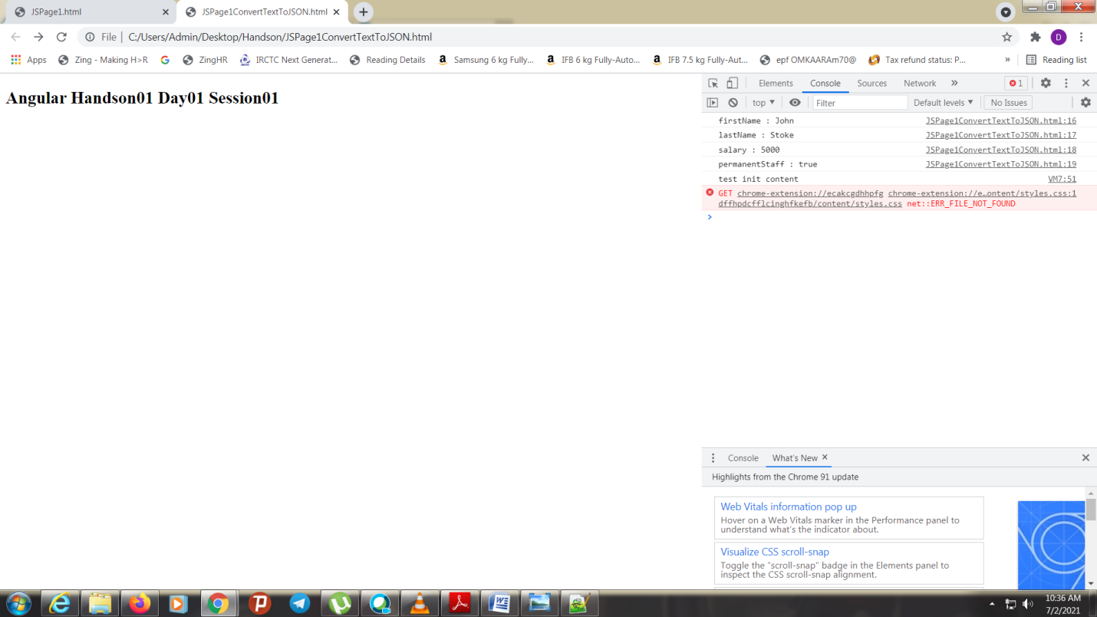

**After Adding Department Details :**

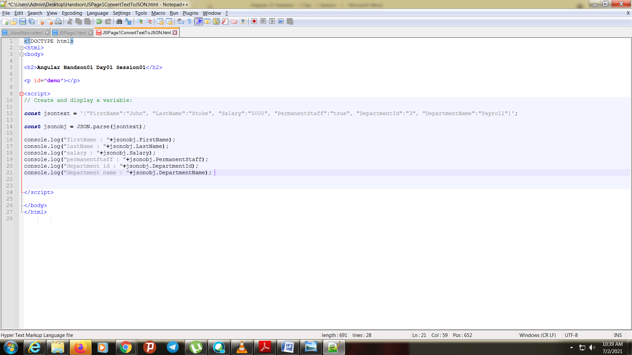

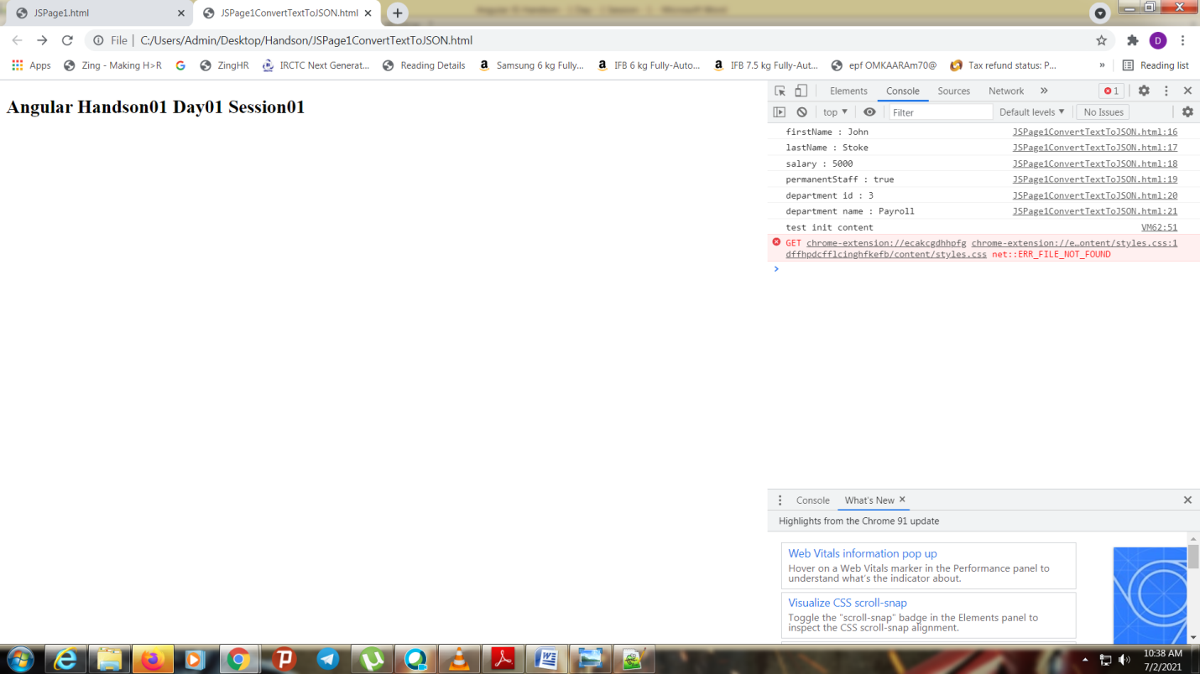

**After Adding Skills :**

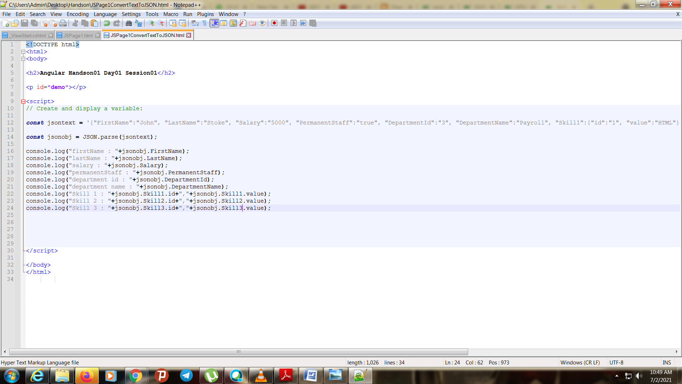

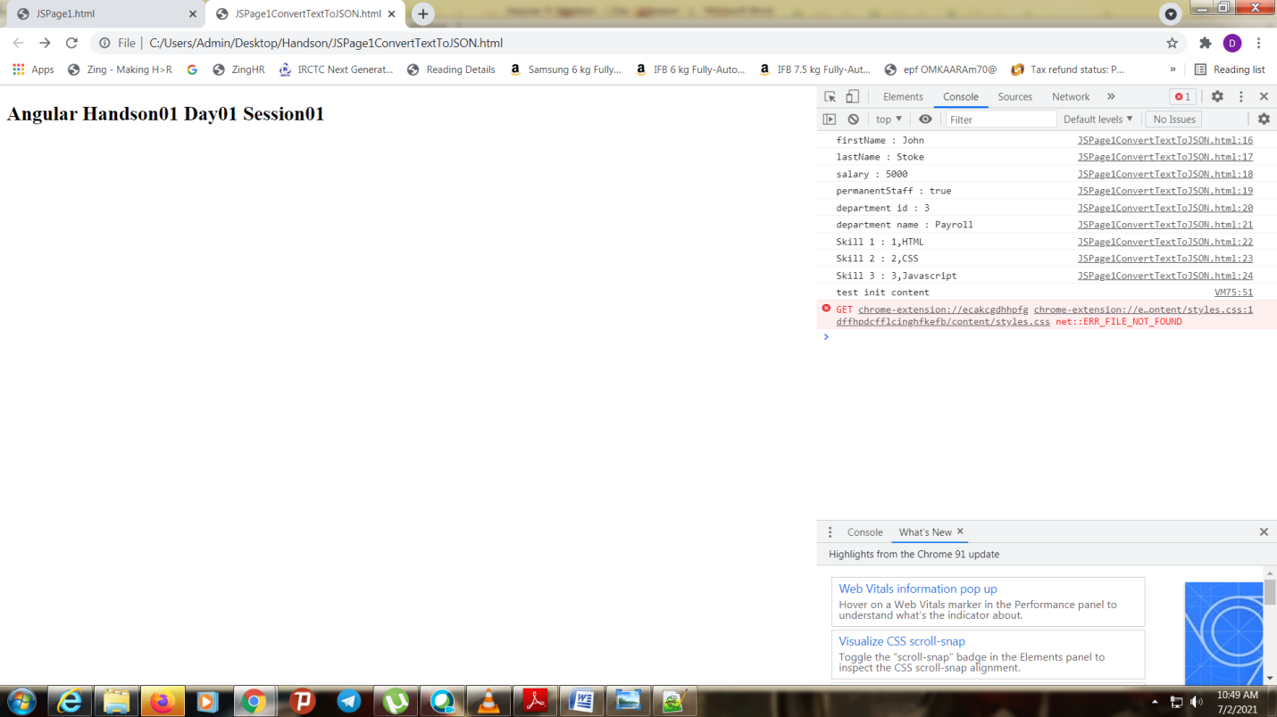

**Get Users : (from reqres.in/api/users)**

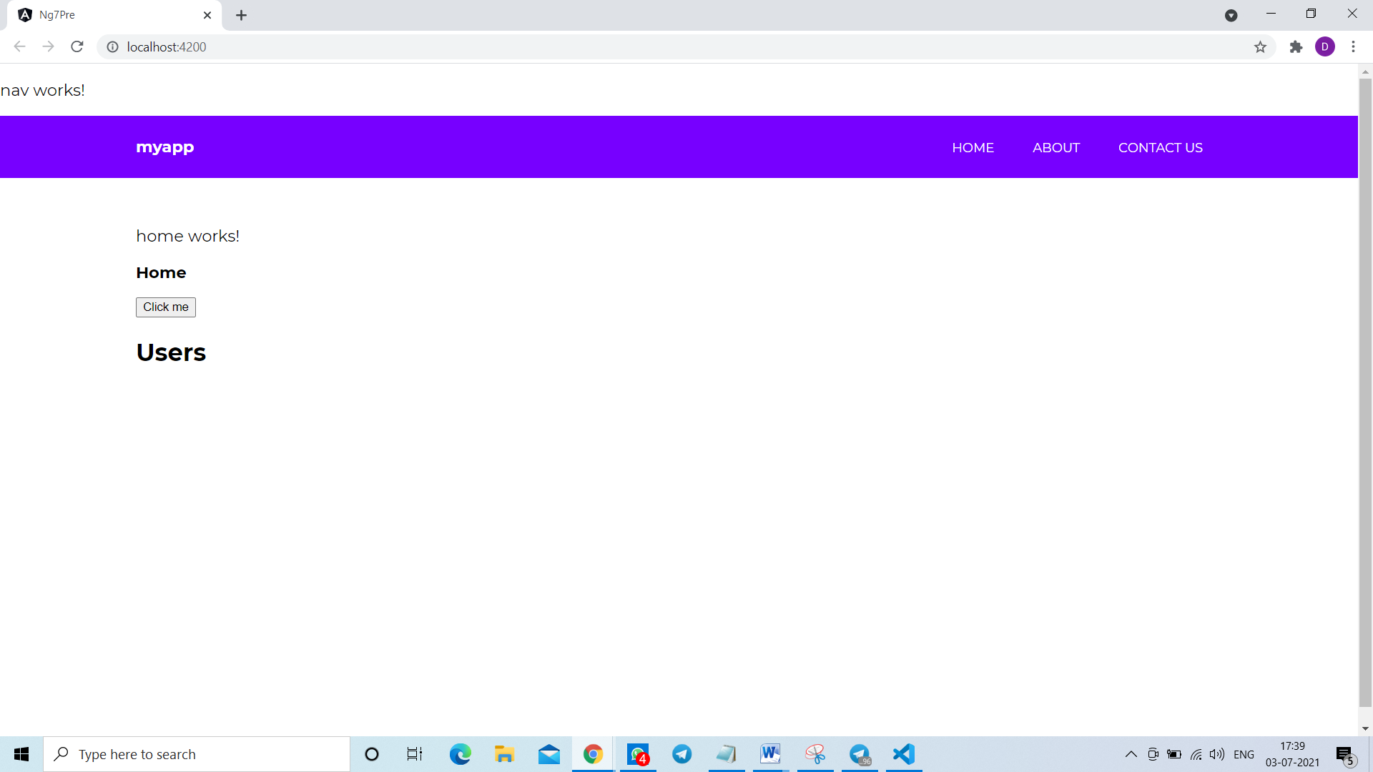

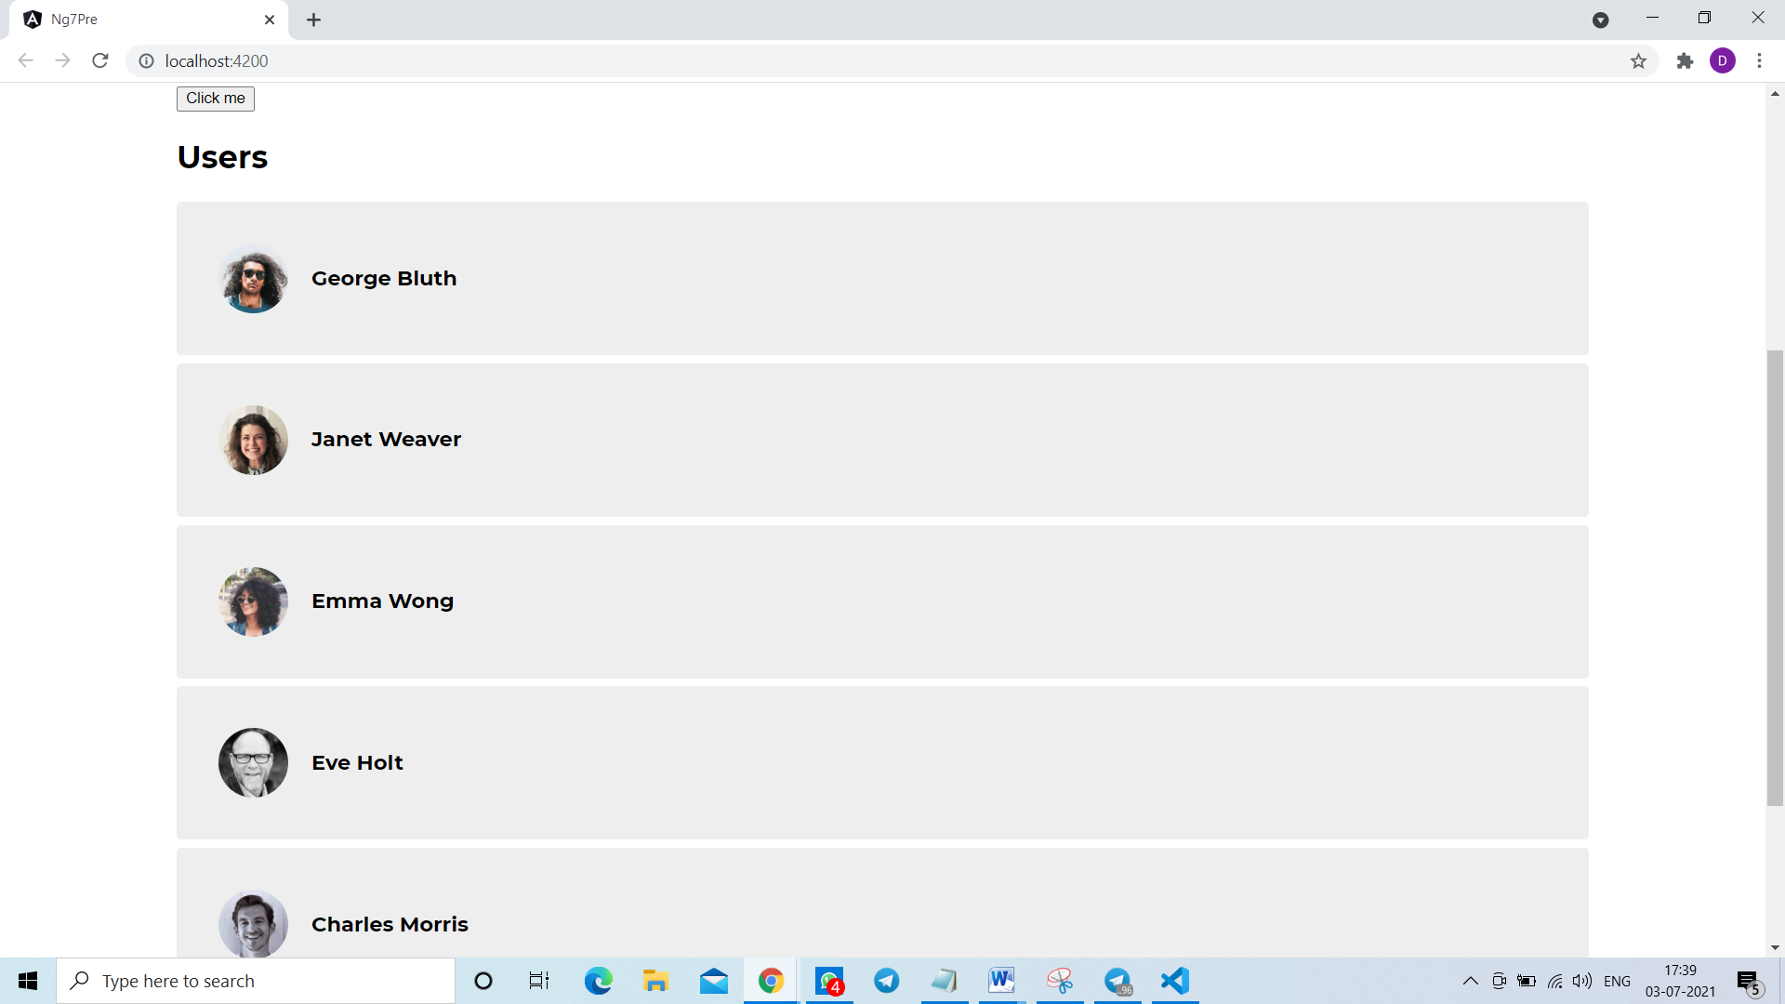

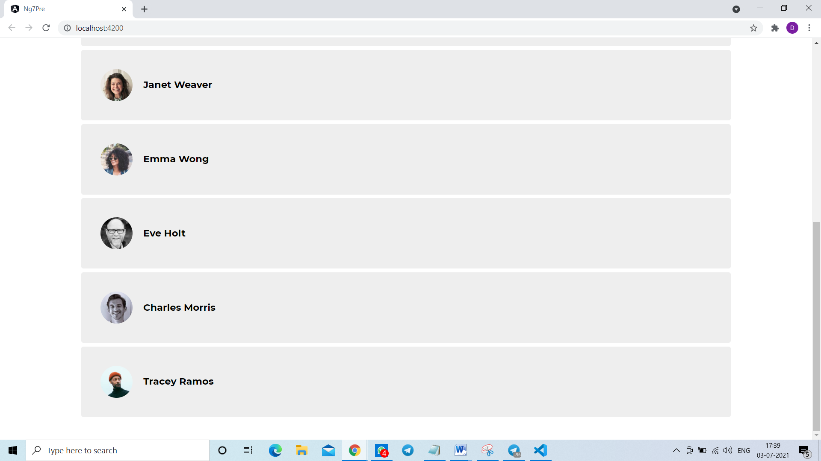

**Service used : (data.service.ts)**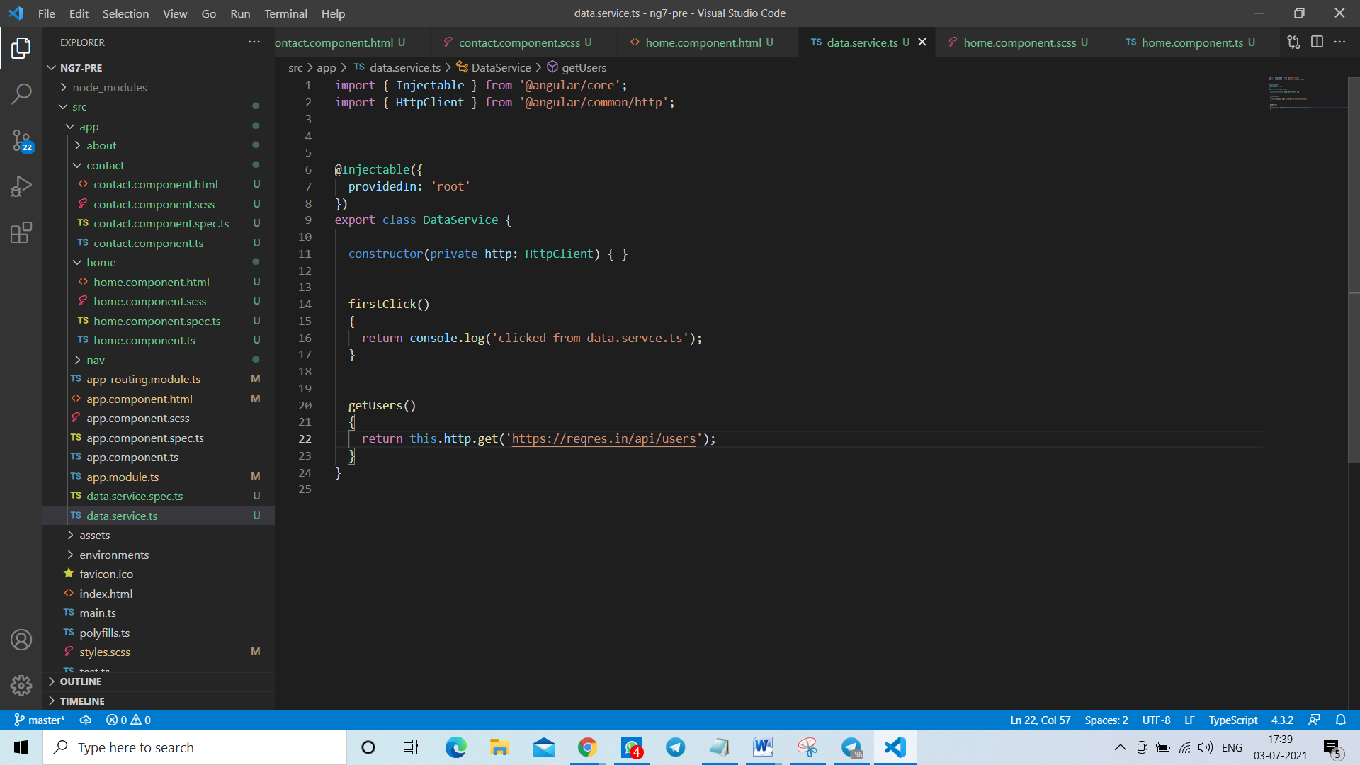

**Through dependency injection, subscribed the data from data service into home component and printed the details by initializing an object variable (users) to the data received and printed them through home.component.html page.**

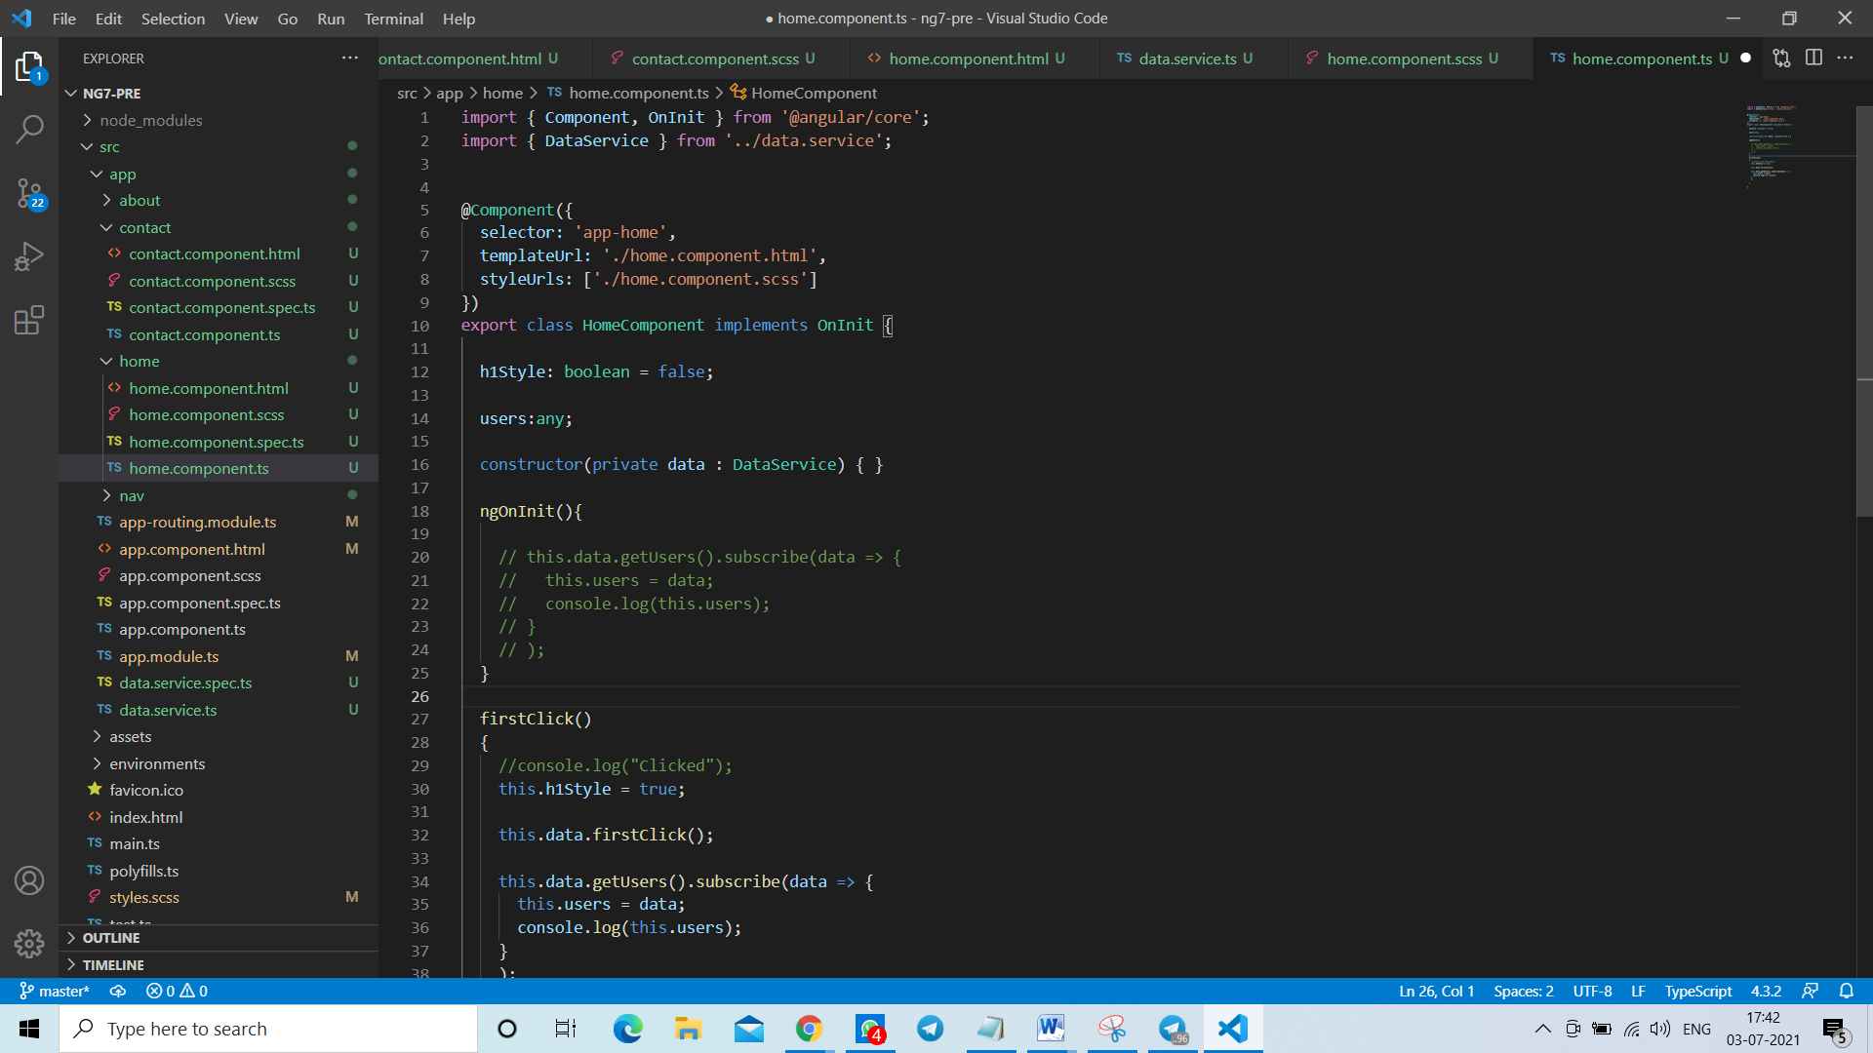

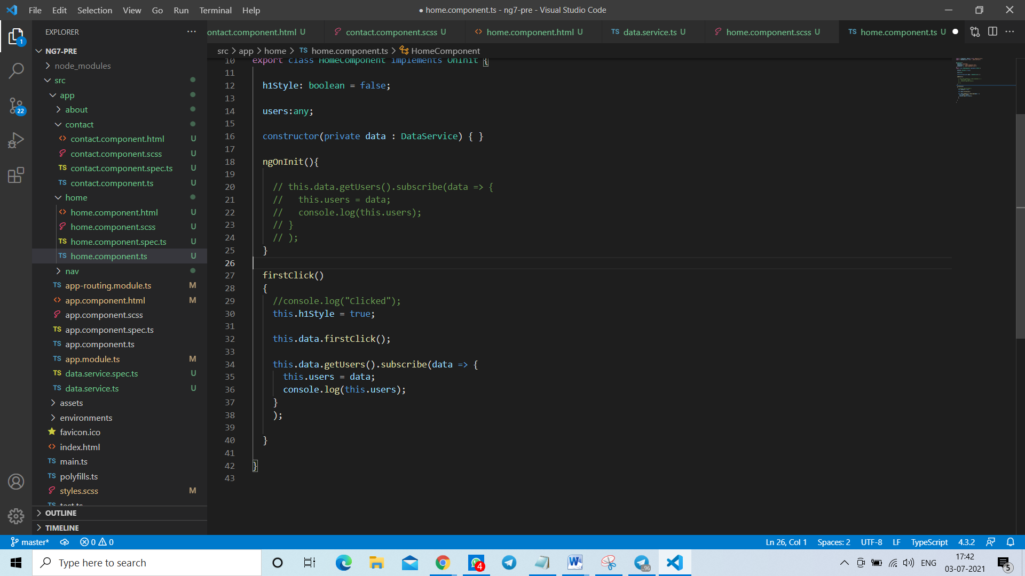

**The solution that has been given in the document uses user.service.ts. I have done the same way, but the service that I created and renamed it as data.service.ts**

**Difference Between a Single Page application and MultiPage Application :**

A single page application (SPA) is a web application or website that interacts with the user by dynamically rewriting the current webpage with new data from the web server, instead of the default method of a web browser loading entire new pages.

Multi-page applications are more SEO-friendly in comparison with single-page solutions. Their content is being constantly updated. Furthermore, they have multiple pages to add various keywords, images, meta tags.

Advantages of using MultiPage applications over Single Page applications :

1. Improved Search Engine Optimization (SEO)
2. Easier to Scale
3. Insightful Data Analytics

Disadvantages of using MultiPage applications over Single page applications :

1. Multi-Page App Development is more difficult and expensive
2. Lower performance indicators
3. Expensive maintenance

Whereas, SPAs are much more lightweight in nature when compared to alternative app types. They don't required any content reloads, don't make users wait for too long to access a web page, as well as have all the data loaded automatically.

Eg: Gmail, Twitter, Facebook, Google Maps, etc.

Advantages of SPAs are :

1. Faster Page Load Time.
2. Easier and Faster to Develop
3. Ability to Work Offline
4. Enhanced User Experience
5. Base for Mobile Applications

On the other hand, SPAs do not perform well in cases of Search Engine optimizations and Security Issues.